**Name:**  Muhammad Bilal

**Father Name:** Haneef Qureshi

**Section:** A

**Teacher:** Dr. Shahab Ahmed Siddique

**Course:** CSSE - 313

**Seat Number:** EB-20103075

**Program:** BSSE

**Department:** UBIT

**Assignment:** Lab

**Q1.** Make a Project Plan of at least 50 activities for the following types of projects: [2.5 marks each]

**a. Applying Booch Method**

**b. Applying RUP**

**c. Applying Waterfall**

**d. Applying Spiral**

Choose your own system.

**A.** I have chosen **Bank Management System­**. Bank Management System is based on dot NET and is a major project for students. It is used to Keep the records of clients, employee etc. in Bank. The bank management system is an application for maintaining a person’s account in a bank . The system provides the access to the customer to create an account, deposit/withdraw the cash from his account, also to view reports of all accounts present. The following presentation provides the specification for the system.

Following are the **Projects Plan** for **Bank Management System.**

**(a)**

|  |  |  |  |  |  |  |  |  |  |  |  |  |  |  |  |  |  |  |  |  |  |  |  |  |  |  |  |  |  |  |  |  |  |  |  |  |  |  |  |
| --- | --- | --- | --- | --- | --- | --- | --- | --- | --- | --- | --- | --- | --- | --- | --- | --- | --- | --- | --- | --- | --- | --- | --- | --- | --- | --- | --- | --- | --- | --- | --- | --- | --- | --- | --- | --- | --- | --- | --- |
| Plan Activities  **Grady Booch Method** | August | | | | September | | | | October | | | | | | | November  **Start Date : August 1st, 2020**  **End Date : January 31st, 2021**  1 | | | | | | | | December | | | | | | | | January | | | | | | | |
| MACRO PROCESS | | | | | | | | | | | | | | | | | | | | | | | | | | | | | | | | | | | | | | | | |
| CONCEPTUALIZATION | | | | | | | | | | | | | | | | | | | | | | | | | | | | | | | | | | | | | | | | |
| Market Research |  |  |  |  |  |  |  |  |  |  | |  | |  | |  | |  | |  | |  | |  | |  | |  | |  | |  | |  | |  | |  | |
| Analyze Industrial Trends |  |  |  |  |  |  |  |  |  |  | |  | |  | |  | |  | |  | |  | |  | |  | |  | |  | |  | |  | |  | |  | |
| Research on Predefined Models |  |  |  |  |  |  |  |  |  |  | |  | |  | |  | |  | |  | |  | |  | |  | |  | |  | |  | |  | |  | |  | |
| Analyze Previous Data |  |  |  |  |  |  |  |  |  |  | |  | |  | |  | |  | |  | |  | |  | |  | |  | |  | |  | |  | |  | |  | |
| Analyze Previous Design |  |  |  |  |  |  |  |  |  |  | |  | |  | |  | |  | |  | |  | |  | |  | |  | |  | |  | |  | |  | |  | |
| Creating a New Model |  |  |  |  |  |  |  |  |  |  | |  | |  | |  | |  | |  | |  | |  | |  | |  | |  | |  | |  | |  | |  | |
| Passing Test Cases |  |  |  |  |  |  |  |  |  |  | |  | |  | |  | |  | |  | |  | |  | |  | |  | |  | |  | |  | |  | |  | |
| Calculation of Model Success |  |  |  |  |  |  |  |  |  |  | |  | |  | |  | |  | |  | |  | |  | |  | |  | |  | |  | |  | |  | |  | |
| Conceptualization Documentation |  |  |  |  |  |  |  |  |  |  | |  | |  | |  | |  | |  | |  | |  | |  | |  | |  | |  | |  | |  | |  | |
| ANALYSIS | | | | | | | | | | | | | | | | | | | | | | | | | | | | | | | | | | | | | | | | |
| Feasibility Study |  |  |  |  |  |  |  |  |  |  | |  | |  | |  | |  | |  | |  | |  | |  | |  | |  | |  | |  | |  | |  | |
| Economic Feasibility |  |  |  |  |  |  |  |  |  |  | |  | |  | |  | |  | |  | |  | |  | |  | |  | |  | |  | |  | |  | |  | |
| Technical Feasibility |  |  |  |  |  |  |  |  |  |  | |  | |  | |  | |  | |  | |  | |  | |  | |  | |  | |  | |  | |  | |  | |
| Operational Feasibility |  |  |  |  |  |  |  |  |  |  | |  | |  | |  | |  | |  | |  | |  | |  | |  | |  | |  | |  | |  | |  | |
| Negotiation and Discussion |  |  |  |  |  |  |  |  |  |  | |  | |  | |  | |  | |  | |  | |  | |  | |  | |  | |  | |  | |  | |  | |
| Software Requirement Verification |  |  |  |  |  |  |  |  |  |  | |  | |  | |  | |  | |  | |  | |  | |  | |  | |  | |  | |  | |  | |  | |
| Software Requirement Validation |  |  |  |  |  |  |  |  |  |  | |  | |  | |  | |  | |  | |  | |  | |  | |  | |  | |  | |  | |  | |  | |
| SRS Documentation |  |  |  |  |  |  |  |  |  |  | |  | |  | |  | |  | |  | |  | |  | |  | |  | |  | |  | |  | |  | |  | |
| Brainstorming |  |  |  |  |  |  |  |  |  |  | |  | |  | |  | |  | |  | |  | |  | |  | |  | |  | |  | |  | |  | |  | |
| Analyzing requirements |  |  |  |  |  |  |  |  |  |  | |  | |  | |  | |  | |  | |  | |  | |  | |  | |  | |  | |  | |  | |  | |
| Requirements modeling |  |  |  |  |  |  |  |  |  |  | |  | |  | |  | |  | |  | |  | |  | |  | |  | |  | |  | |  | |  | |  | |
| Security Requirements |  |  |  |  |  |  |  |  |  |  | |  | |  | |  | |  | |  | |  | |  | |  | |  | |  | |  | |  | |  | |  | |
| DESIGN | | | | | | | | | | | | | | | | | | | | | | | | | | | | | | | | | | | | | | | | |
| Identify Design Goals |  |  |  |  |  |  |  |  |  |  | |  | |  | |  | |  | |  | |  | |  | |  | |  | |  | |  | |  | |  | |  | |
| System Decomposition |  |  |  |  |  |  |  |  |  |  | |  | |  | |  | |  | |  | |  | |  | |  | |  | |  | |  | |  | |  | |  | |
| Logical Design |  |  |  |  |  |  |  |  |  |  | |  | |  | |  | |  | |  | |  | |  | |  | |  | |  | |  | |  | |  | |  | |
| Physical Design |  |  |  |  |  |  |  |  |  |  | |  | |  | |  | |  | |  | |  | |  | |  | |  | |  | |  | |  | |  | |  | |
| Architectural Design |  |  |  |  |  |  |  |  |  |  | |  | |  | |  | |  | |  | |  | |  | |  | |  | |  | |  | |  | |  | |  | |
| Detailed Design |  |  |  |  |  |  |  |  |  |  | |  | |  | |  | |  | |  | |  | |  | |  | |  | |  | |  | |  | |  | |  | |
| Conceptual Data Modeling |  |  |  |  |  |  |  |  |  |  | |  | |  | |  | |  | |  | |  | |  | |  | |  | |  | |  | |  | |  | |  | |
| Design Management |  |  |  |  |  |  |  |  |  |  | |  | |  | |  | |  | |  | |  | |  | |  | |  | |  | |  | |  | |  | |  | |
| Data Flow Design |  |  |  |  |  |  |  |  |  |  | |  | |  | |  | |  | |  | |  | |  | |  | |  | |  | |  | |  | |  | |  | |
| Data Structure Oriented Design |  |  |  |  |  |  |  |  |  |  | |  | |  | |  | |  | |  | |  | |  | |  | |  | |  | |  | |  | |  | |  | |
| Object-Oriented Design |  |  |  |  |  |  |  |  |  |  | |  | |  | |  | |  | |  | |  | |  | |  | |  | |  | |  | |  | |  | |  | |
| Designing Documentation |  |  |  |  |  |  |  |  |  | |  | |  | |  | |  | |  | |  | |  | |  | |  | |  | |  | |  | |  | |  | |  | | |
| CODING AND IMPLEMENTATION | | | | | | | | | | | | | | | | | | | | | | | | | | | | | | | | | | | | | | | | |
| Banking Module Coding |  |  |  |  |  |  |  |  |  |  | |  | |  | |  | |  | |  | |  | |  | |  | |  | |  | |  | |  | |  | |  | |
| Unit Testing of Banking Module |  |  |  |  |  |  |  |  |  |  | |  | |  | |  | |  | |  | |  | |  | |  | |  | |  | |  | |  | |  | |  | |
| Administrative Module Coding |  |  |  |  |  |  |  |  |  |  | |  | |  | |  | |  | |  | |  | |  | |  | |  | |  | |  | |  | |  | |  | |
| Unit Testing of Administrative Module  Coding |  |  |  |  |  |  |  |  |  |  | |  | |  | |  | |  | |  | |  | |  | |  | |  | |  | |  | |  | |  | |  | |
| User Module Coding |  |  |  |  |  |  |  |  |  |  | |  | |  | |  | |  | |  | |  | |  | |  | |  | |  | |  | |  | |  | |  | |
| Unit Testing of Admin Module Coding |  |  |  |  |  |  |  |  |  |  | |  | |  | |  | |  | |  | |  | |  | |  | |  | |  | |  | |  | |  | |  | |
| Unit Testing of Admin Coding |  |  |  |  |  |  |  |  |  |  | |  | |  | |  | |  | |  | |  | |  | |  | |  | |  | |  | |  | |  | |  | |
| Unit Testing of User Module Coding |  |  |  |  |  |  |  |  |  |  | |  | |  | |  | |  | |  | |  | |  | |  | |  | |  | |  | |  | |  | |  | |
| Unit Testing of User Coding |  |  |  |  |  |  |  |  |  |  | |  | |  | |  | |  | |  | |  | |  | |  | |  | |  | |  | |  | |  | |  | |
| Deployment Preparations |  |  |  |  |  |  |  |  |  |  | |  | |  | |  | |  | |  | |  | |  | |  | |  | |  | |  | |  | |  | |  | |
| Deploying the Solution |  |  |  |  |  |  |  |  |  |  | |  | |  | |  | |  | |  | |  | |  | |  | |  | |  | |  | |  | |  | |  | |
| Stabilizing the Deployment |  |  |  |  |  |  |  |  |  |  | |  | |  | |  | |  | |  | |  | |  | |  | |  | |  | |  | |  | |  | |  | |
| Deployment Documentation |  |  |  |  |  |  |  |  |  |  | |  | |  | |  | |  | |  | |  | |  | |  | |  | |  | |  | |  | |  | |  | |
| MAINTENANCE | | | | | | | | | | | | | | | | | | | | | | | | | | | | | | | | | | | | | | | | |
| Identification and Tracing |  |  |  |  |  |  |  |  |  |  | |  | |  | |  | |  | |  | |  | |  | |  | |  | |  | |  | |  | |  | |  | |
| Corrective Maintenance |  |  |  |  |  |  |  |  |  |  | |  | |  | |  | |  | |  | |  | |  | |  | |  | |  | |  | |  | |  | |  | |
| Adaptive Maintenance |  |  |  |  |  |  |  |  |  |  | |  | |  | |  | |  | |  | |  | |  | |  | |  | |  | |  | |  | |  | |  | |
| Perfective Maintenance |  |  |  |  |  |  |  |  |  |  | |  | |  | |  | |  | |  | |  | |  | |  | |  | |  | |  | |  | |  | |  | |
| Preventive Maintenance |  |  |  |  |  |  |  |  |  |  | |  | |  | |  | |  | |  | |  | |  | |  | |  | |  | |  | |  | |  | |  | |
| Maintenance Management |  |  |  |  |  |  |  |  |  |  | |  | |  | |  | |  | |  | |  | |  | |  | |  | |  | |  | |  | |  | |  | |
| Version Tracking |  |  |  |  |  |  |  |  |  |  | |  | |  | |  | |  | |  | |  | |  | |  | |  | |  | |  | |  | |  | |  | |
| Releasing Patches |  |  |  |  |  |  |  |  |  |  | |  | |  | |  | |  | |  | |  | |  | |  | |  | |  | |  | |  | |  | |  | |
| MICRO PROCESS (ITERATIVE) | | | | | | | | | | | | | | | | | | | | | | | | | | | | | | | | | | | | | | | | |
| IDENTIFICATION OF CLASSES AND OBJECTS | | | | | | | | | | | | | | | | | | | | | | | | | | | | | | | | | | | | | | | | |
| Identify Classes |  |  |  |  |  |  |  |  |  |  | |  | |  | |  | |  | |  | |  | |  | |  | |  | |  | |  | |  | |  | |  | |
| Identify Objects |  |  |  |  |  |  |  |  |  |  | |  | |  | |  | |  | |  | |  | |  | |  | |  | |  | |  | |  | |  | |  | |
| Define Classes |  |  |  |  |  |  |  |  |  |  | |  | |  | |  | |  | |  | |  | |  | |  | |  | |  | |  | |  | |  | |  | |
| Define Objects |  |  |  |  |  |  |  |  |  |  | |  | |  | |  | |  | |  | |  | |  | |  | |  | |  | |  | |  | |  | |  | |
| Define Relation between Classes |  |  |  |  |  |  |  |  |  |  | |  | |  | |  | |  | |  | |  | |  | |  | |  | |  | |  | |  | |  | |  | |
| Define Relation between Objects |  |  |  |  |  |  |  |  |  |  | |  | |  | |  | |  | |  | |  | |  | |  | |  | |  | |  | |  | |  | |  | |
| IDENTIFICATION OF THEIR SEMANTICS | | | | | | | | | | | | | | | | | | | | | | | | | | | | | | | | | | | | | | | | |
| Creation of Initial Design Classes |  |  |  |  |  |  |  |  |  |  | |  | |  | |  | |  | |  | |  | |  | |  | |  | |  | |  | |  | |  | |  | |
| [Identify Persistent Classes](https://sceweb.uhcl.edu/helm/RationalUnifiedProcess/process/activity/ac_cldes.htm#Define%20Persistent%20Classes) |  |  |  |  |  |  |  |  |  |  | |  | |  | |  | |  | |  | |  | |  | |  | |  | |  | |  | |  | |  | |  | |
| [Define Class Visibility](https://sceweb.uhcl.edu/helm/RationalUnifiedProcess/process/activity/ac_cldes.htm#Define%20Class%20Visibility) |  |  |  |  |  |  |  |  |  |  | |  | |  | |  | |  | |  | |  | |  | |  | |  | |  | |  | |  | |  | |  | |
| Define Operations |  |  |  |  |  |  |  |  |  |  | |  | |  | |  | |  | |  | |  | |  | |  | |  | |  | |  | |  | |  | |  | |
| Define Methods |  |  |  |  |  |  |  |  |  |  | |  | |  | |  | |  | |  | |  | |  | |  | |  | |  | |  | |  | |  | |  | |
| Define States |  |  |  |  |  |  |  |  |  |  | |  | |  | |  | |  | |  | |  | |  | |  | |  | |  | |  | |  | |  | |  | |
| Define Attributes |  |  |  |  |  |  |  |  |  |  | |  | |  | |  | |  | |  | |  | |  | |  | |  | |  | |  | |  | |  | |  | |
| [Define Dependencies](https://sceweb.uhcl.edu/helm/RationalUnifiedProcess/process/activity/ac_cldes.htm#Define%20Dependencies) |  |  |  |  |  |  |  |  |  |  | |  | |  | |  | |  | |  | |  | |  | |  | |  | |  | |  | |  | |  | |  | |
| [Define Associations](https://sceweb.uhcl.edu/helm/RationalUnifiedProcess/process/activity/ac_cldes.htm#Define%20Associations) |  |  |  |  |  |  |  |  |  |  | |  | |  | |  | |  | |  | |  | |  | |  | |  | |  | |  | |  | |  | |  | |
| [Define Generalizations](https://sceweb.uhcl.edu/helm/RationalUnifiedProcess/process/activity/ac_cldes.htm#Define%20Generalizations) |  |  |  |  |  |  |  |  |  |  | |  | |  | |  | |  | |  | |  | |  | |  | |  | |  | |  | |  | |  | |  | |
| IDENTIFICATION OF THEIR RELATIONSHIP | | | | | | | | | | | | | | | | | | | | | | | | | | | | | | | | | | | | | | | | |
| Identify Inheritance |  |  |  |  |  |  |  |  |  |  | |  | |  | |  | |  | |  | |  | |  | |  | |  | |  | |  | |  | |  | |  | |
| Single inheritance |  |  |  |  |  |  |  |  |  |  | |  | |  | |  | |  | |  | |  | |  | |  | |  | |  | |  | |  | |  | |  | |
| Multi-level inheritance |  |  |  |  |  |  |  |  |  |  | |  | |  | |  | |  | |  | |  | |  | |  | |  | |  | |  | |  | |  | |  | |
| Multiple inheritance |  |  |  |  |  |  |  |  |  |  | |  | |  | |  | |  | |  | |  | |  | |  | |  | |  | |  | |  | |  | |  | |
| Multipath inheritance |  |  |  |  |  |  |  |  |  |  | |  | |  | |  | |  | |  | |  | |  | |  | |  | |  | |  | |  | |  | |  | |
| Hierarchical Inheritance |  |  |  |  |  |  |  |  |  |  | |  | |  | |  | |  | |  | |  | |  | |  | |  | |  | |  | |  | |  | |  | |
| Hybrid Inheritance |  |  |  |  |  |  |  |  |  |  | |  | |  | |  | |  | |  | |  | |  | |  | |  | |  | |  | |  | |  | |  | |
| IDENTIFICATION OF THEIR INTERFACES AND IMPLEMENTAION | | | | | | | | | | | | | | | | | | | | | | | | | | | | | | | | | | | | | | | | |
| Identify Interface |  |  |  |  |  |  |  |  |  |  | |  | |  | |  | |  | |  | |  | |  | |  | |  | |  | |  | |  | |  | |  | |
| Identify Abstract Classes |  |  |  |  |  |  |  |  |  |  | |  | |  | |  | |  | |  | |  | |  | |  | |  | |  | |  | |  | |  | |  | |
| Define Interface |  |  |  |  |  |  |  |  |  |  | |  | |  | |  | |  | |  | |  | |  | |  | |  | |  | |  | |  | |  | |  | |
| Define Abstract Classes |  |  |  |  |  |  |  |  |  |  | |  | |  | |  | |  | |  | |  | |  | |  | |  | |  | |  | |  | |  | |  | |

**(b)**

|  |  |  |  |  |  |  |  |  |  |  |  |  |  |  |
| --- | --- | --- | --- | --- | --- | --- | --- | --- | --- | --- | --- | --- | --- | --- |
|  |  |  |  |  | |  |  | |  | |  |  |  | |
|  |  |  |  |  | |  |  | |  | |  |  |
|  |  |  |  |  | |  |  | |  | |  |  |
|  |  |  |  |  | |  |  | |  | |  |  |
|  |  |  |  |  | |  |  | |  | |  |  |
|  |  |  |  | **Start Date** | | | **February 6, 2021** | | | | |  |
|  |  |  | **Rational Unified Process** | **End Date** | | | **April 16, 2021** | | | | |  |
|  |  |  |  |  | |  |  | |  | |  |  |
|  |  |  |  |  |  | | |  | |
| **PLAN ACTIVITIES** | | **Week 1** | **Week 2** | **Week 3** | | **Week 4** | **Week 5** | | **Week 6** | | **Week 7** | **Week 8** | **Week 9** | **Week 10** |
| February | February | February | | February | March | | March | | March | March | April | April |
| 6 | 13 | 20 | | 27 | 3 | | 10 | | 17 | 24 | 7 | 16 |
| **INCEPTION** | Feasibility Study |  |  |  | |  |  | |  | |  |  |  |  |
| Economic Feasibility | v |  |  | |  |  | |  | |  |  |  |  |
| Technical Feasibility |  |  |  | |  |  | |  | |  |  |  |  |
| Operational Feasibility |  |  |  | |  |  | |  | |  |  |  |  |
| Negotiation and Discussion |  |  |  | |  |  | |  | |  |  |  |  |
| Software Requirement Verification |  |  |  | |  |  | |  | |  |  |  |  |
| Software Requirement Validation |  |  |  | |  |  | |  | |  |  |  |  |
| SRS Documentation |  |  |  | |  |  | |  | |  |  |  |  |
| Brainstorming |  |  |  | |  |  | |  | |  |  |  |  |
| Analyzing requirements |  |  |  | |  |  | |  | |  |  |  |  |
| Requirements modeling |  |  |  | |  |  | |  | |  |  |  |  |
| Security Requirements |  |  |  | |  |  | |  | |  |  |  |  |
| **ELABORATION** | Define Baseline |  |  |  | |  |  | |  | |  |  |  |  |
| Define Architecture |  |  |  | |  |  | |  | |  |  |  |  |
| Identify Design Goals |  |  |  | |  |  | |  | |  |  |  |  |
| System Decomposition |  |  |  | |  |  | |  | |  |  |  |  |
| Logical Design |  |  |  | |  |  | |  | |  |  |  |  |
| Physical Design |  |  |  | |  |  | |  | |  |  |  |  |
| Architectural Design |  |  |  | |  |  | |  | |  |  |  |  |
| Detailed Design |  |  |  | |  |  | |  | |  |  |  |  |
| Conceptual Data Modeling |  |  |  | |  |  | |  | |  |  |  |  |
| Design Management |  |  |  | |  |  | |  | |  |  |  |  |
| Data Flow Design |  |  |  | |  |  | |  | |  |  |  |  |
| Data Structure Oriented Design |  |  |  | |  |  | |  | |  |  |  |  |
| Object-Oriented Design |  |  |  | |  |  | |  | |  |  |  |  |
| Designing Documentation |  |  |  | |  |  | |  | |  |  |  |  |
| **CONSTRUCTION** | Banking Module Coding |  |  |  | |  |  | |  | |  |  |  |  |
| Unit Testing of Banking Module |  |  |  | |  |  | |  | |  |  |  |  |
| Administrative Module Coding |  |  |  | |  |  | |  | |  |  |  |  |
| Unit Testing of Administrative Module  Coding |  |  |  | |  |  | |  | |  |  |  |  |
| User Module Coding |  |  |  | |  |  | |  | |  |  |  |  |
| Unit Testing of Admin Module Coding |  |  |  | |  |  | |  | |  |  |  |  |
| Unit Testing of Admin Coding |  |  |  | |  |  | |  | |  |  |  |  |
| Unit Testing of User Module Coding |  |  |  | |  |  | |  | |  |  |  |  |
| Front-end Coding |  |  |  | |  |  | |  | |  |  |  |  |
| Back-end Coding |  |  |  | |  |  | |  | |  |  |  |  |
| Database Coding |  |  |  | |  |  | |  | |  |  |  |  |
| Unit Testing of Database Coding |  |  |  | |  |  | |  | |  |  |  |  |
| Coding Documentation |  |  |  | |  |  | |  | |  |  |  |  |
| **TRANSITION** | Identification and Tracing |  |  |  | |  |  | |  | |  |  |  |  |
| Corrective Maintenance |  |  |  | |  |  | |  | |  |  |  |  |
| Adaptive Maintenance |  |  |  | |  |  | |  | |  |  |  |  |
| Perfective Maintenance |  |  |  | |  |  | |  | |  |  |  |  |
| Preventive Maintenance |  |  |  | |  |  | |  | |  |  |  |  |
| Installation and Activation |  |  |  | |  |  | |  | |  |  |  |  |
| Implement enhancements |  |  |  | |  |  | |  | |  |  |  |  |
| Interface with other systems. |  |  |  | |  |  | |  | |  |  |  |  |
| Maintenance Management |  |  |  | |  |  | |  | |  |  |  |  |
| Version Tracking |  |  |  | |  |  | |  | |  |  |  |  |
| Releasing Patches |  |  |  | |  |  | |  | |  |  |  |  |
| Retirement of Old Version. |  |  |  | |  |  | |  | |  |  |  |  |

**(c)**

|  |  |  |  |  |  |  |  |  |  |  |  |
| --- | --- | --- | --- | --- | --- | --- | --- | --- | --- | --- | --- |
| **Waterfall Project Plan** |  |  |  |  |  |  |  |  |  |  | |
|  |  |  |  |  |  |  |  |  |  |
|  |  |  |  |  |  |  |  |  |  |
|  |  |  |  |  |  |  |  |  |  |
|  |  |  |  |  |  |  |  |  |  |
|  |  |  |  | **Start Date** | | **January 6, 2020** | | |  |
|  |  |  |  | **End Date** | | **March 16, 2020** | | |  |
|  |  |  |  |  |  |  |  |  |  |
|  |  |  |  |  |  |  |  |  |  |
| **PLAN ACTIVITIES** | | **Week 1** | **Week 2** | **Week 3** | **Week 4** | **Week 5** | **Week 6** | **Week 7** | **Week 8** | **Week 9** | **Week 10** |
| January | January | January | January | February | February | February | February | March | March |
| 6 | 13 | 20 | 27 | 3 | 10 | 17 | 24 | 7 | 16 |
| **REQUIREMENT GATHERING**  **& ANALYSIS** | Feasibility Study |  |  |  |  |  |  |  |  |  |  |
| Economic Feasibility |  |  |  |  |  |  |  |  |  |  |
| Technical Feasibility |  |  |  |  |  |  |  |  |  |  |
| Operational Feasibility |  |  |  |  |  |  |  |  |  |  |
| Negotiation and Discussion |  |  |  |  |  |  |  |  |  |  |
| Software Requirement Verification |  |  |  |  |  |  |  |  |  |  |
| Software Requirement Validation |  |  |  |  |  |  |  |  |  |  |
| SRS Documentation |  |  |  |  |  |  |  |  |  |  |
| **SYSTEM DESIGN** | Identify Design Goals |  |  |  |  |  |  |  |  |  |  |
| System Decomposition |  |  |  |  |  |  |  |  |  |  |
| Logical Design |  |  |  |  |  |  |  |  |  |  |
| Physical Design |  |  |  |  |  |  |  |  |  |  |
| Architectural Design |  |  |  |  |  |  |  |  |  |  |
| Detailed Design |  |  |  |  |  |  |  |  |  |  |
| Conceptual Data Modeling |  |  |  |  |  |  |  |  |  |  |
| Design Management |  |  |  |  |  |  |  |  |  |  |
| **IMPLEMENTATION** | Banking Module Coding |  |  |  |  |  |  |  |  |  |  |
| Unit Testing of Banking Module |  |  |  |  |  |  |  |  |  |  |
| Administrative Module Coding |  |  |  |  |  |  |  |  |  |  |
| Unit Testing of Administrative Module  Coding |  |  |  |  |  |  |  |  |  |  |
| User Module Coding |  |  |  |  |  |  |  |  |  |  |
| Unit Testing of Admin Module Coding |  |  |  |  |  |  |  |  |  |  |
| Unit Testing of Admin Coding |  |  |  |  |  |  |  |  |  |  |
| Unit Testing of User Module Coding |  |  |  |  |  |  |  |  |  |  |
| Coding Documentation |  |  |  |  |  |  |  |  |  |  |
| **INTEGRATION & TSETING** | Integration of Components |  |  |  |  |  |  |  |  |  |  |
| Integration of Modules |  |  |  |  |  |  |  |  |  |  |
| Integration Testing |  |  |  |  |  |  |  |  |  |  |
| System Testing |  |  |  |  |  |  |  |  |  |  |
| Bottom-up Integration Testing |  |  |  |  |  |  |  |  |  |  |
| Incremental Testing |  |  |  |  |  |  |  |  |  |  |
| Big Bang Testing |  |  |  |  |  |  |  |  |  |  |
| Acceptance Testing |  |  |  |  |  |  |  |  |  |  |
| **DEPLOYMENT OF SYSTEM** | Creating Operation Procedures |  |  |  |  |  |  |  |  |  |  |
| Deployment Preparations |  |  |  |  |  |  |  |  |  |  |
| Deploying the Solution |  |  |  |  |  |  |  |  |  |  |
| Core Technology Deployment |  |  |  |  |  |  |  |  |  |  |
| Site Deployments |  |  |  |  |  |  |  |  |  |  |
| Stabilizing the Deployment |  |  |  |  |  |  |  |  |  |  |
| Transferring Ownership to Operations Team |  |  |  |  |  |  |  |  |  |  |
| Closing the Deploying Phase |  |  |  |  |  |  |  |  |  |  |
| **MAINTENANCE** | Identification and Tracing |  |  |  |  |  |  |  |  |  |  |
| Corrective Maintenance |  |  |  |  |  |  |  |  |  |  |
| Adaptive Maintenance |  |  |  |  |  |  |  |  |  |  |
| Perfective Maintenance |  |  |  |  |  |  |  |  |  |  |
| Preventive Maintenance |  |  |  |  |  |  |  |  |  |  |
| Installation and Activation |  |  |  |  |  |  |  |  |  |  |
| Maintenance Management |  |  |  |  |  |  |  |  |  |  |
| Version Tracking |  |  |  |  |  |  |  |  |  |  |
| Releasing Patches |  |  |  |  |  |  |  |  |  |  |

**(d)**

|  |  |  |  |  |  |  |  |  |  |  |  |  |  |  |  |  |  |  |  |  |  |  |  |  |
| --- | --- | --- | --- | --- | --- | --- | --- | --- | --- | --- | --- | --- | --- | --- | --- | --- | --- | --- | --- | --- | --- | --- | --- | --- |
| Plan Activities  **Spiral Model**(ITERATIVE) | January | | | | February | | | | March | | | | April  **Start Date : January 1st, 2020**  **End Date : July 31st, 2020** | | | | June | | | | July | | | |
| IDENTIFICATION | | | | | | | | | | | | | | | | | | | | | | | | |
| Feasibility Study |  |  |  |  |  |  |  |  |  |  |  |  |  |  |  |  |  |  |  |  |  |  |  |  |
| Economic Feasibility |  |  |  |  |  |  |  |  |  |  |  |  |  |  |  |  |  |  |  |  |  |  |  |  |
| Technical Feasibility |  |  |  |  |  |  |  |  |  |  |  |  |  |  |  |  |  |  |  |  |  |  |  |  |
| Operational Feasibility |  |  |  |  |  |  |  |  |  |  |  |  |  |  |  |  |  |  |  |  |  |  |  |  |
| Negotiation and Discussion |  |  |  |  |  |  |  |  |  |  |  |  |  |  |  |  |  |  |  |  |  |  |  |  |
| Software Requirement Verification |  |  |  |  |  |  |  |  |  |  |  |  |  |  |  |  |  |  |  |  |  |  |  |  |
| Software Requirement Validation |  |  |  |  |  |  |  |  |  |  |  |  |  |  |  |  |  |  |  |  |  |  |  |  |
| SRS Documentation |  |  |  |  |  |  |  |  |  |  |  |  |  |  |  |  |  |  |  |  |  |  |  |  |
| Brainstorming |  |  |  |  |  |  |  |  |  |  |  |  |  |  |  |  |  |  |  |  |  |  |  |  |
| Analyzing requirements |  |  |  |  |  |  |  |  |  |  |  |  |  |  |  |  |  |  |  |  |  |  |  |  |
| Requirements modeling |  |  |  |  |  |  |  |  |  |  |  |  |  |  |  |  |  |  |  |  |  |  |  |  |
| Security Requirements |  |  |  |  |  |  |  |  |  |  |  |  |  |  |  |  |  |  |  |  |  |  |  |  |
| SYSTEM DESIGN | | | | | | | | | | | | | | | | | | | | | | | | |
| Identify Design Goals |  |  |  |  |  |  |  |  |  |  |  |  |  |  |  |  |  |  |  |  |  |  |  |  |
| System Decomposition |  |  |  |  |  |  |  |  |  |  |  |  |  |  |  |  |  |  |  |  |  |  |  |  |
| Logical Design |  |  |  |  |  |  |  |  |  |  |  |  |  |  |  |  |  |  |  |  |  |  |  |  |
| Physical Design |  |  |  |  |  |  |  |  |  |  |  |  |  |  |  |  |  |  |  |  |  |  |  |  |
| Architectural Design |  |  |  |  |  |  |  |  |  |  |  |  |  |  |  |  |  |  |  |  |  |  |  |  |
| Detailed Design |  |  |  |  |  |  |  |  |  |  |  |  |  |  |  |  |  |  |  |  |  |  |  |  |
| Conceptual Data Modeling |  |  |  |  |  |  |  |  |  |  |  |  |  |  |  |  |  |  |  |  |  |  |  |  |
| Design Management |  |  |  |  |  |  |  |  |  |  |  |  |  |  |  |  |  |  |  |  |  |  |  |  |
| Data Flow Design |  |  |  |  |  |  |  |  |  |  |  |  |  |  |  |  |  |  |  |  |  |  |  |  |
| Data Structure Oriented Design |  |  |  |  |  |  |  |  |  |  |  |  |  |  |  |  |  |  |  |  |  |  |  |  |
| Object-Oriented Design |  |  |  |  |  |  |  |  |  |  |  |  |  |  |  |  |  |  |  |  |  |  |  |  |
| Designing Documentation |  |  |  |  |  |  |  |  |  |  |  |  |  |  |  |  |  |  |  |  |  |  |  |  |
| CODING | | | | | | | | | | | | | | | | | | | | | | | | |
| Banking Module Coding |  |  |  |  |  |  |  |  |  |  |  |  |  |  |  |  |  |  |  |  |  |  |  |  |
| Unit Testing of Banking Module |  |  |  |  |  |  |  |  |  |  |  |  |  |  |  |  |  |  |  |  |  |  |  |  |
| Administrative Module Coding |  |  |  |  |  |  |  |  |  |  |  |  |  |  |  |  |  |  |  |  |  |  |  |  |
| Unit Testing of Administrative Module  Coding |  |  |  |  |  |  |  |  |  |  |  |  |  |  |  |  |  |  |  |  |  |  |  |  |
| User Module Coding |  |  |  |  |  |  |  |  |  |  |  |  |  |  |  |  |  |  |  |  |  |  |  |  |
| Unit Testing of Admin Module Coding |  |  |  |  |  |  |  |  |  |  |  |  |  |  |  |  |  |  |  |  |  |  |  |  |
| Unit Testing of Admin Coding |  |  |  |  |  |  |  |  |  |  |  |  |  |  |  |  |  |  |  |  |  |  |  |  |
| Unit Testing of User Module Coding |  |  |  |  |  |  |  |  |  |  |  |  |  |  |  |  |  |  |  |  |  |  |  |  |
| Coding Documentation |  |  |  |  |  |  |  |  |  |  |  |  |  |  |  |  |  |  |  |  |  |  |  |  |
| Front-end Coding |  |  |  |  |  |  |  |  |  |  |  |  |  |  |  |  |  |  |  |  |  |  |  |  |
| Back-end Coding |  |  |  |  |  |  |  |  |  |  |  |  |  |  |  |  |  |  |  |  |  |  |  |  |
| Unit Testing of Back-end Coding |  |  |  |  |  |  |  |  |  |  |  |  |  |  |  |  |  |  |  |  |  |  |  |  |
| Database Coding |  |  |  |  |  |  |  |  |  |  |  |  |  |  |  |  |  |  |  |  |  |  |  |  |
| Unit Testing of Database Coding |  |  |  |  |  |  |  |  |  |  |  |  |  |  |  |  |  |  |  |  |  |  |  |  |
| Coding Documentation |  |  |  |  |  |  |  |  |  |  |  |  |  |  |  |  |  |  |  |  |  |  |  |  |
| RISK ANALYIS AND EVOLUATION | | | | | | | | | | | | | | | | | | | | | | | | |
| Identify Risk |  |  |  |  |  |  |  |  |  |  |  |  |  |  |  |  |  |  |  |  |  |  |  |  |
| Risk Sources |  |  |  |  |  |  |  |  |  |  |  |  |  |  |  |  |  |  |  |  |  |  |  |  |
| Risk Category |  |  |  |  |  |  |  |  |  |  |  |  |  |  |  |  |  |  |  |  |  |  |  |  |
| Analyze Risk |  |  |  |  |  |  |  |  |  |  |  |  |  |  |  |  |  |  |  |  |  |  |  |  |
| Prioritize Risk |  |  |  |  |  |  |  |  |  |  |  |  |  |  |  |  |  |  |  |  |  |  |  |  |
| Probability of Risk Occurrence |  |  |  |  |  |  |  |  |  |  |  |  |  |  |  |  |  |  |  |  |  |  |  |  |
| Risk Impact |  |  |  |  |  |  |  |  |  |  |  |  |  |  |  |  |  |  |  |  |  |  |  |  |
| Risk Exposure |  |  |  |  |  |  |  |  |  |  |  |  |  |  |  |  |  |  |  |  |  |  |  |  |
| Risk Occurrence Timeframe |  |  |  |  |  |  |  |  |  |  |  |  |  |  |  |  |  |  |  |  |  |  |  |  |
| Risk Triggers |  |  |  |  |  |  |  |  |  |  |  |  |  |  |  |  |  |  |  |  |  |  |  |  |
| Risk Response Plan |  |  |  |  |  |  |  |  |  |  |  |  |  |  |  |  |  |  |  |  |  |  |  |  |
| Risk Audit |  |  |  |  |  |  |  |  |  |  |  |  |  |  |  |  |  |  |  |  |  |  |  |  |

**Q2.** Apply online tools of **COCOMO I** and **COCOMO II** on the following projects: [2.5 marks each]

**a. Take every factor as Average and LOC as 50K**

**b. Take every factor as Simple and LOC as 50K**

**c. Take every factor as Complex , Highly Influence and LOC as 50K**

**d. Take every factor as Average and FP = 500**

Submit the report of these system from the tool.

**(a)**

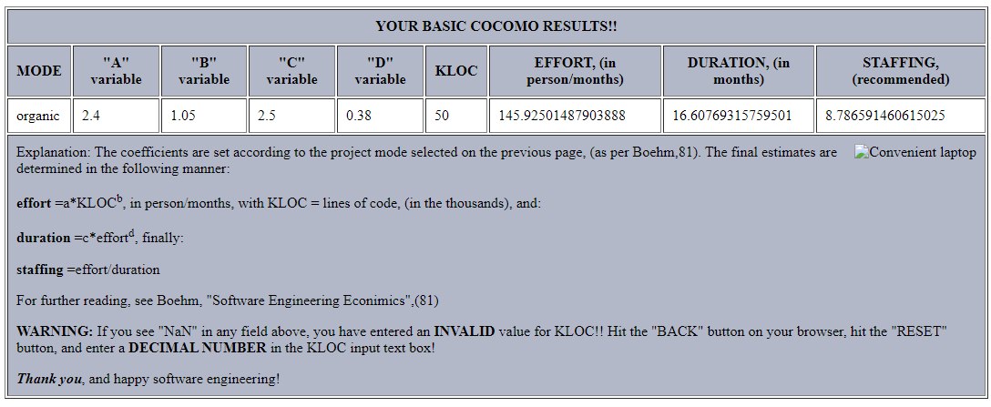

**(b)**

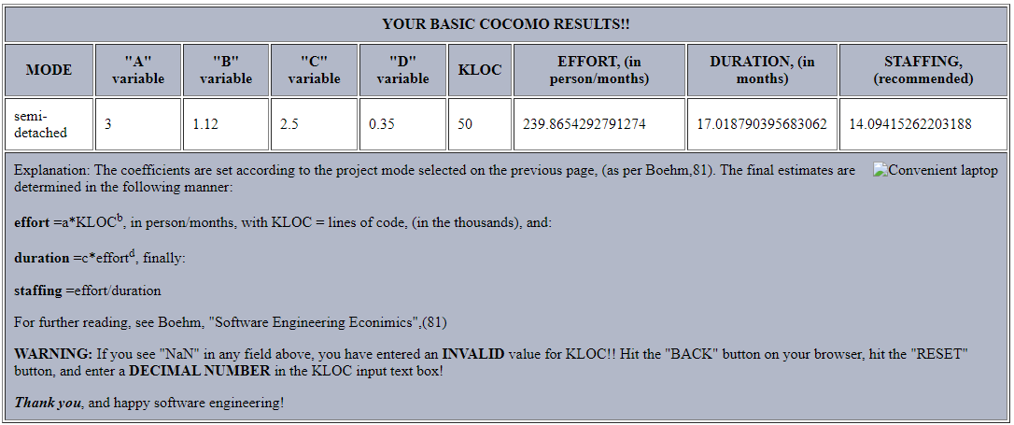

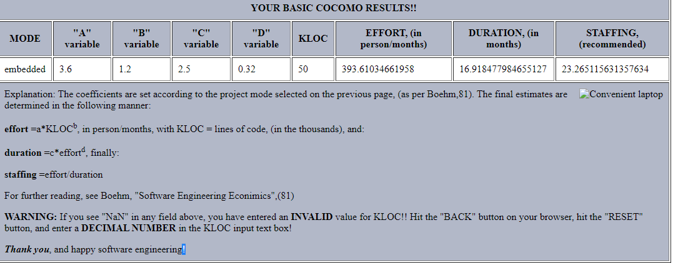**(c)**

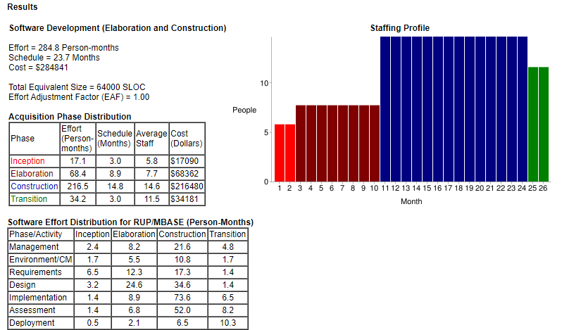**(d)**